https://www.nationalgeographic.com/travel/article/across-the-border-this-mexican-community-also-celebrates-juneteenth

Just across the border, this Mexican community also celebrates Juneteenth
The “Southern Underground Railroad” helped formerly enslaved people reach freedom in northern Mexico. One village here has observed Juneteenth or “Dia de los Negros” for 150 years.
Adan Salazar, a member of the cabalgata (a parade of horseback riders), travels 20 miles from the neighboring town of Múzquiz to celebrate Juneteenth in 2018 in Nacimiento, the generational home of the Black Seminoles who escaped the threat of slavery in the United States.
By Taryn White
Photographs By Luján Agusti
Published June 17, 2021
In northern Mexico’s Coahuila State there’s a village where locals celebrate Juneteenth by eating traditional Afro-Seminole foods, dancing to norteña music, and practicing capeyuye—hand-clapped hymnals sung by enslaved peoples who traveled the southern Underground Railroad to freedom.
It may seem unlikely that this holiday would be honored in a small village at the base of the Sierra Madre range, but Nacimiento de los Negros—meaning “Birth of the Blacks”—became a haven for the Mascogos, descendants of Black Seminoles who escaped the brutality of the antebellum South and settled in Mexico.
Now, long after the group came to Nacimiento in 1852, a new challenge remains for the Mascogos: Keeping their culture and traditions alive. In a country of approximately 130 million people, where 1.3 million identify as Afro-descendants, there are only a few hundred Mascogos. Decades of navigating ongoing drought conditions in Mexico, currently affecting 84 percent of the country, have devasted the village’s agriculture-based economy. Younger community members have little choice but to seek new opportunities elsewhere.
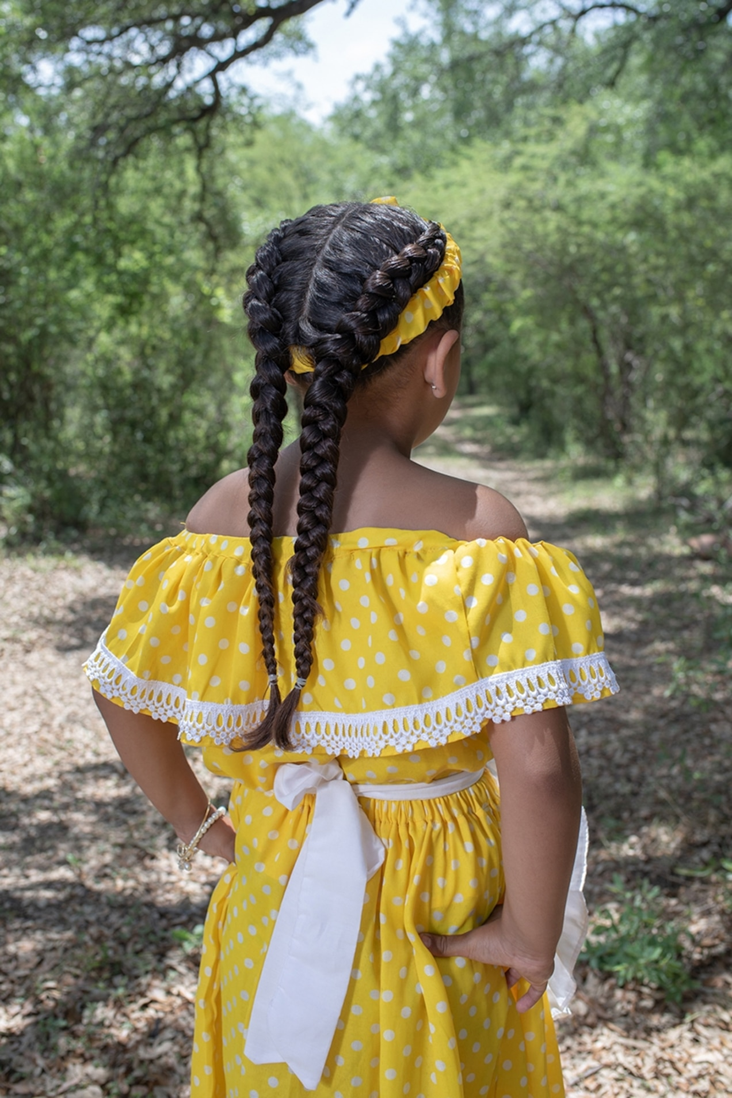
A young girl dons on the traditional attire—polka-dot dress, apron, and handkerchief—worn by Mascogos women during Juneteenth celebrations in Nacimiento.
But there is hope—both in the strength of Mascogo identity and in the growing recognition of Juneteenth (June 19), a day that marks the freedom of enslaved people in Texas at the end of the United States Civil War and is considered by some to be America’s “second Independence Day.” On June 17, President Joseph Biden signed a bill that recognizes Juneteenth as a federal holiday. Such recognition could also strengthen the visibility of this historic community nearly 2,000 miles from Washington. D.C.

The southern underground railroad
Hundreds of enslaved people fled from southern plantations to live among the Seminoles in Florida Territory during the mid-to-late 18th century. Spain granted freedom to enslaved people who escaped to Florida under their rule, but the U.S. did not recognize this agreement.
(Here’s why Juneteenth is a celebration of hope.)
In 1821, the Spanish ceded Florida to the U.S., sending the Seminoles and their Black counterparts farther south onto reservations near the Apalachicola River. Andrew Jackson, territorial governor of Florida, ordered an attack on Angola, a village built by Black Seminoles and other free Blacks near Tampa Bay. Dozens of escaped slaves were captured and sold or returned to their previous place of enslavement; many others were killed.
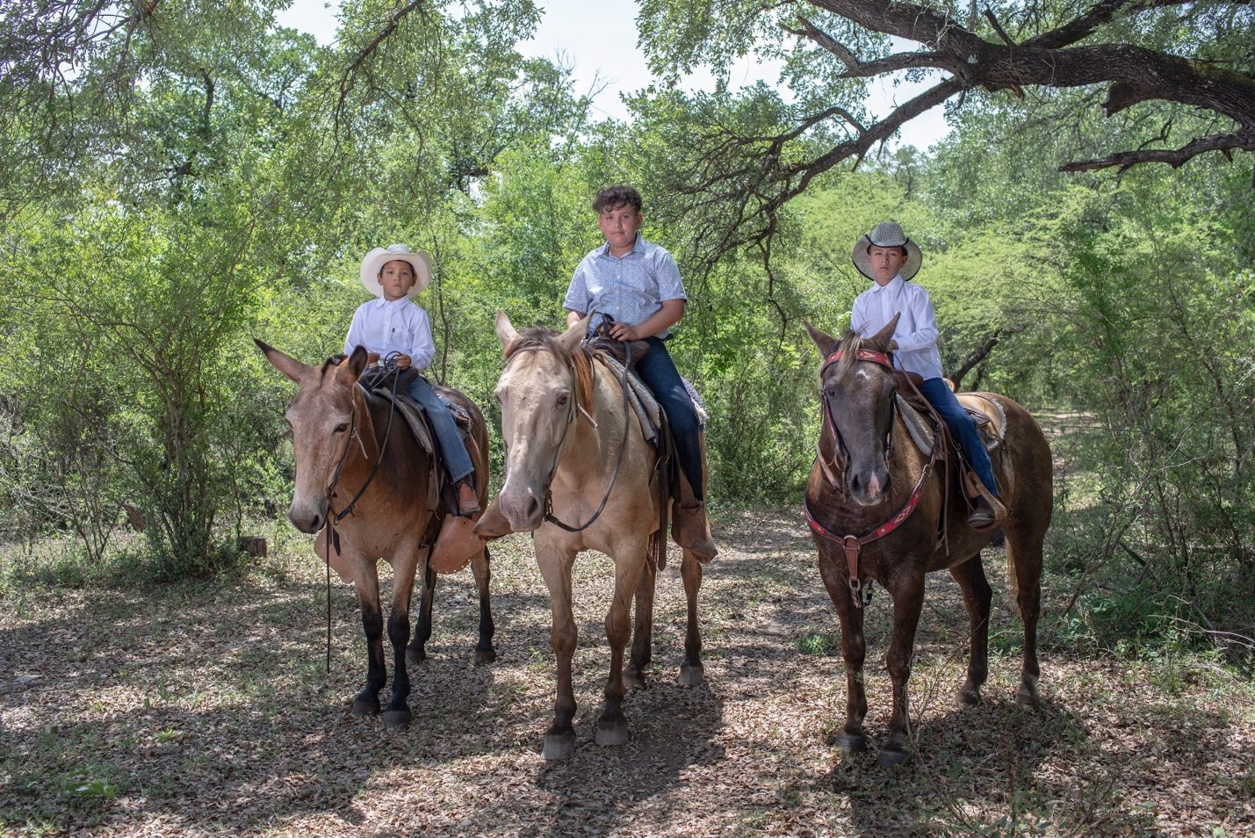
From left to right: Jose, Aton, and Sebastian, members of the horseback parade, arrive in Nacimiento’s nogalera (a park surrounded by walnut trees) as part of Día de Los Negros.
Nearly a decade later, Jackson, now president, signed the Indian Removal Act of 1830 into law, which required Native tribes in the southeast to relocate to Indian Territory in what is now Oklahoma. Seminole and Black leaders opposed the forced removal, later leading to the Second Seminole War (1835–42). Halfway through the confrontation, the Seminoles called for a truce and agreed to move—if their Black allies were allowed to move safely as well.
The negotiations quickly fell through, and the war resumed, but the relocation of nearly 4,000 Seminoles and 800 Black Seminoles, also known as the Trail of Tears, had already begun.

Southern Underground Railroad
As many as 5,000 enslaved African Americans escaped to freedom in Mexico, after that
country outlawed slavery in 1829. While most traveled on their own or in small groups,
some were helped by an informal network of free African Americans, Mexicans, Tejanos,
and German settlers. Motivations for assisting the refugees were complex—some did
so out of sympathy, while others were paid to transport them across the border.
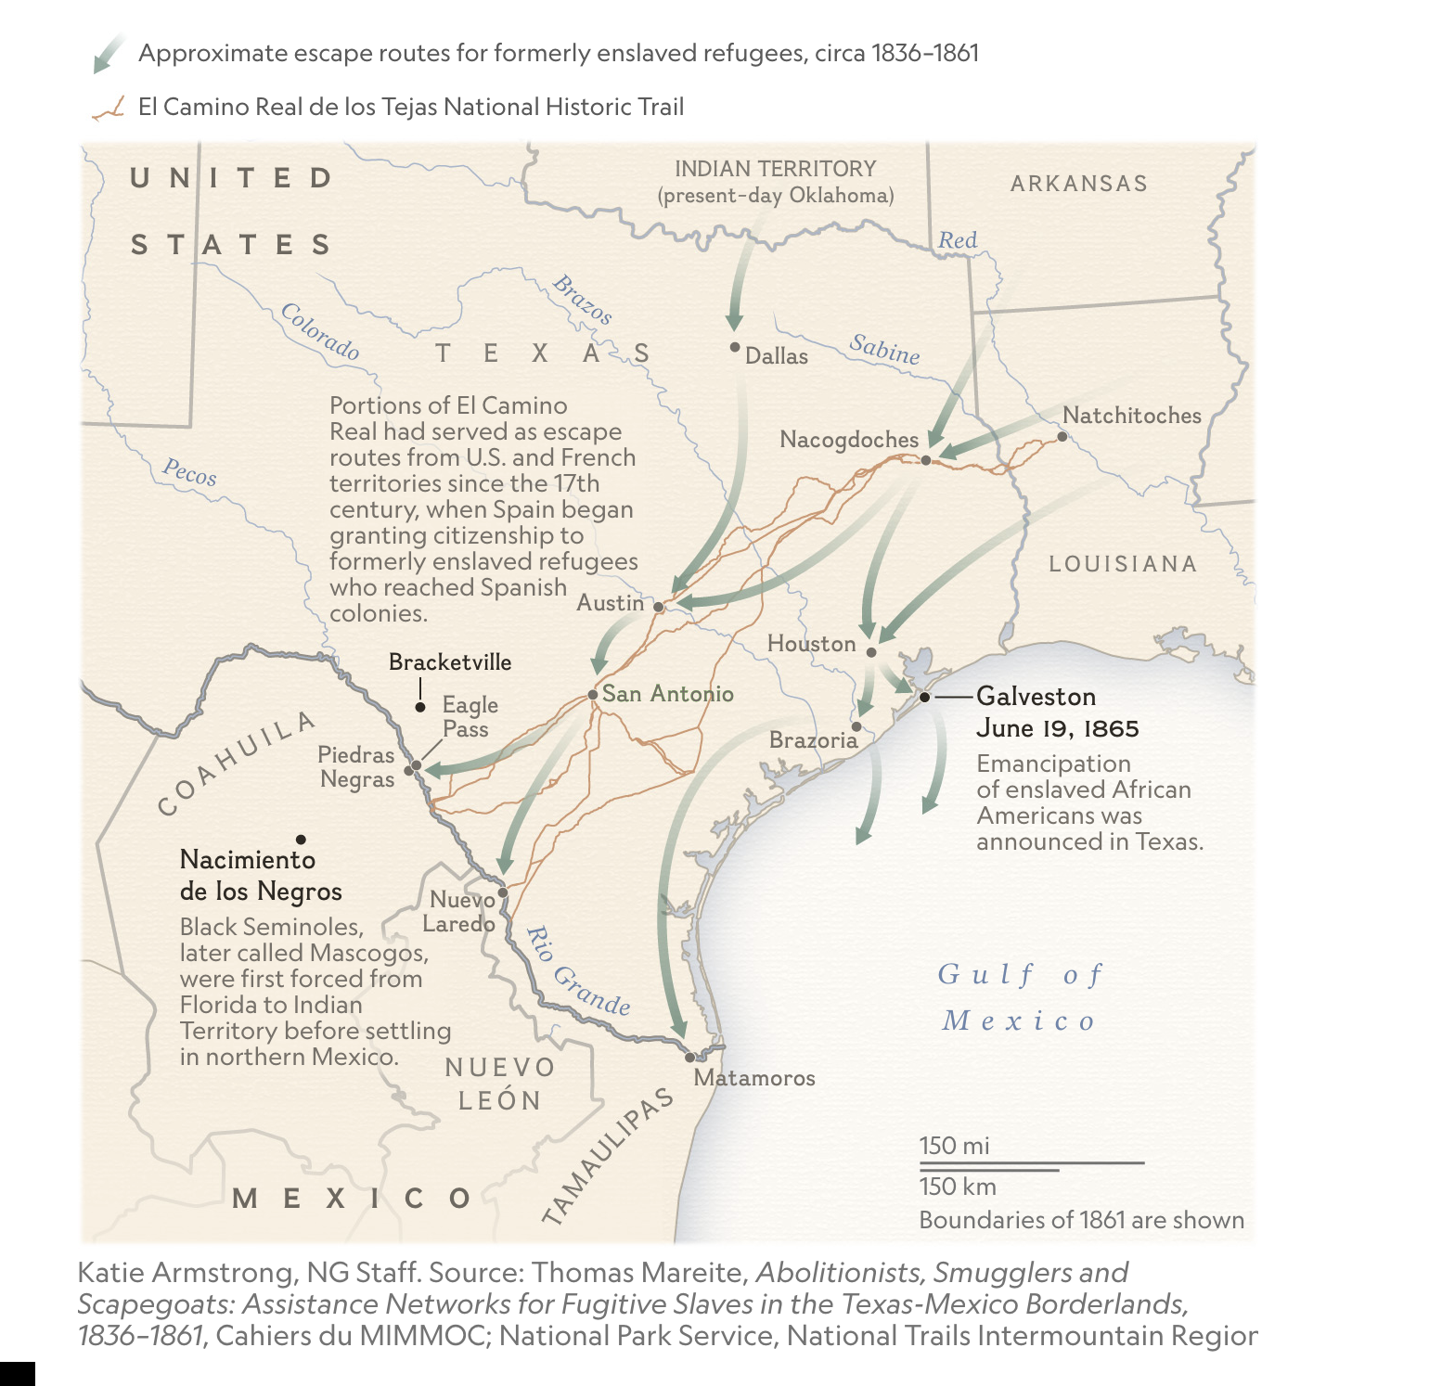
By 1845, most Seminoles had been relocated to Indian Territory, where many Black Seminoles who joined the journey were kidnapped and sold into slavery in Arkansas and Louisiana. Faced with continuous hardships in Indian Territory, members of the Black Seminoles, Seminole Indians, and Kickapoo tribe left Indian Territory in 1849 for Mexico, where slaves could live freely.
Mexico officially abolished slavery in September 1829, and in 1857, Mexico amended its constitution to reflect that all people are born free.
Alice Baumgartner, assistant professor of history at the University of Southern California, says that the Seminoles’ and Black Seminoles’ move to Mexico was part of a much longer history of Mexican authorities recruiting Native peoples who had been forced from their homelands to help defend Mexico’s northern border. In exchange for fighting, they would receive 70,000 acres of land in northern Coahuila as well as livestock, money, and agricultural tools.
“That alternative was far from perfect,” she says, “but it was an alternative nonetheless.”

Juneteenth—in Mexico and the U.S.
Even though the Emancipation Proclamation declared enslaved people in the Confederacy free on January 1, 1863, word had not fully spread to geographically isolated Texas, where slaveholders refused to comply with the federal orders.
It wasn’t until the last battle of the war when Union troops arrived in Galveston, Texas—a full two-and-a-half years after the Emancipation Proclamation was signed—that many enslaved people knew they were free.
(Here’s how two centuries of slave revolts shaped American history.)
One year later, freedmen in Texas organized “Jubilee Day” to commemorate the date, initially holding church-centered gatherings that provided oral history lessons on slavery. Today, the holiday, which is officially recognized in more than 47 states and the District of Columbia, typically includes barbecues, street festivals, parades, religious services, dancing, and sipping red drinks—the last to symbolize the bloodshed of African Americans.
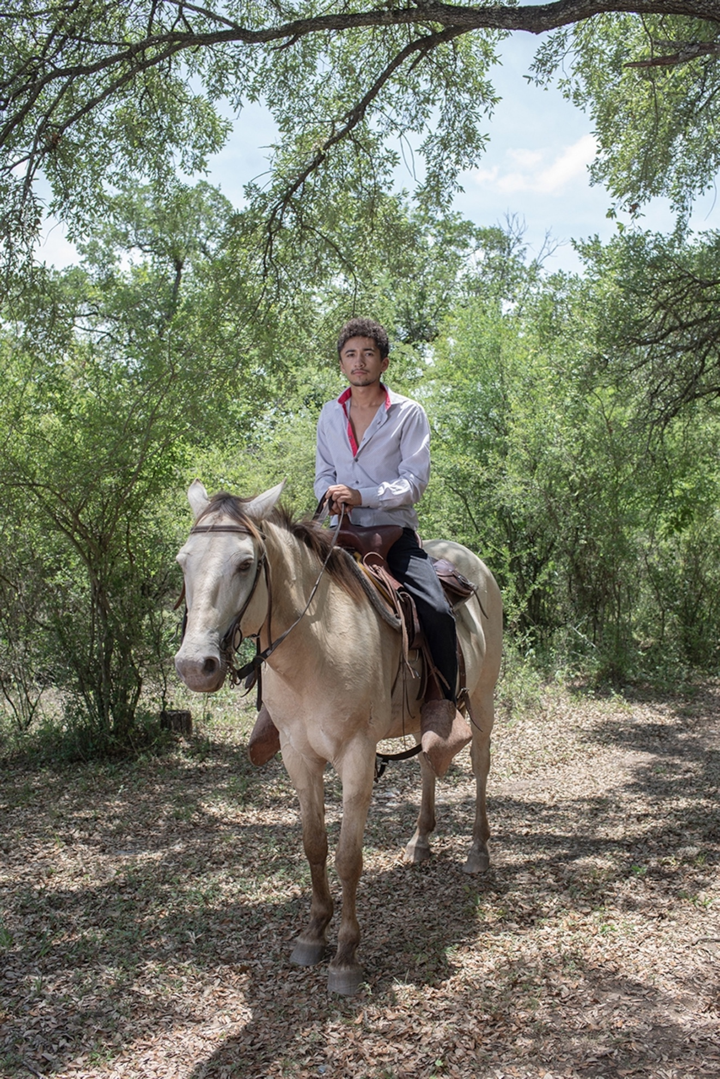
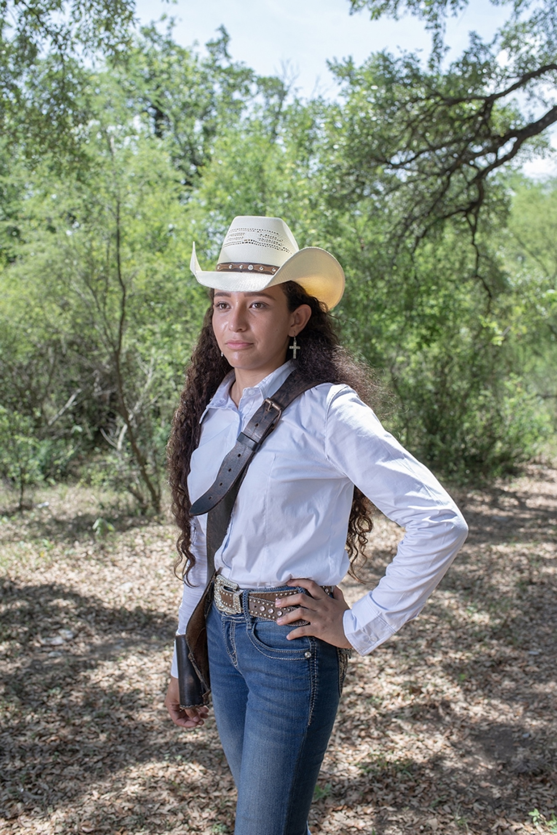
Left: Josue, who is of Mascogo descent, honors the traditions of his community for Juneteenth, which now a federal holiday in the U.S.
Right: Jennie Hidalgo was crowned the Queen of the Jineteada (the town’s pageant) for Nacimiento’s 2018 Juneteenth celebration.
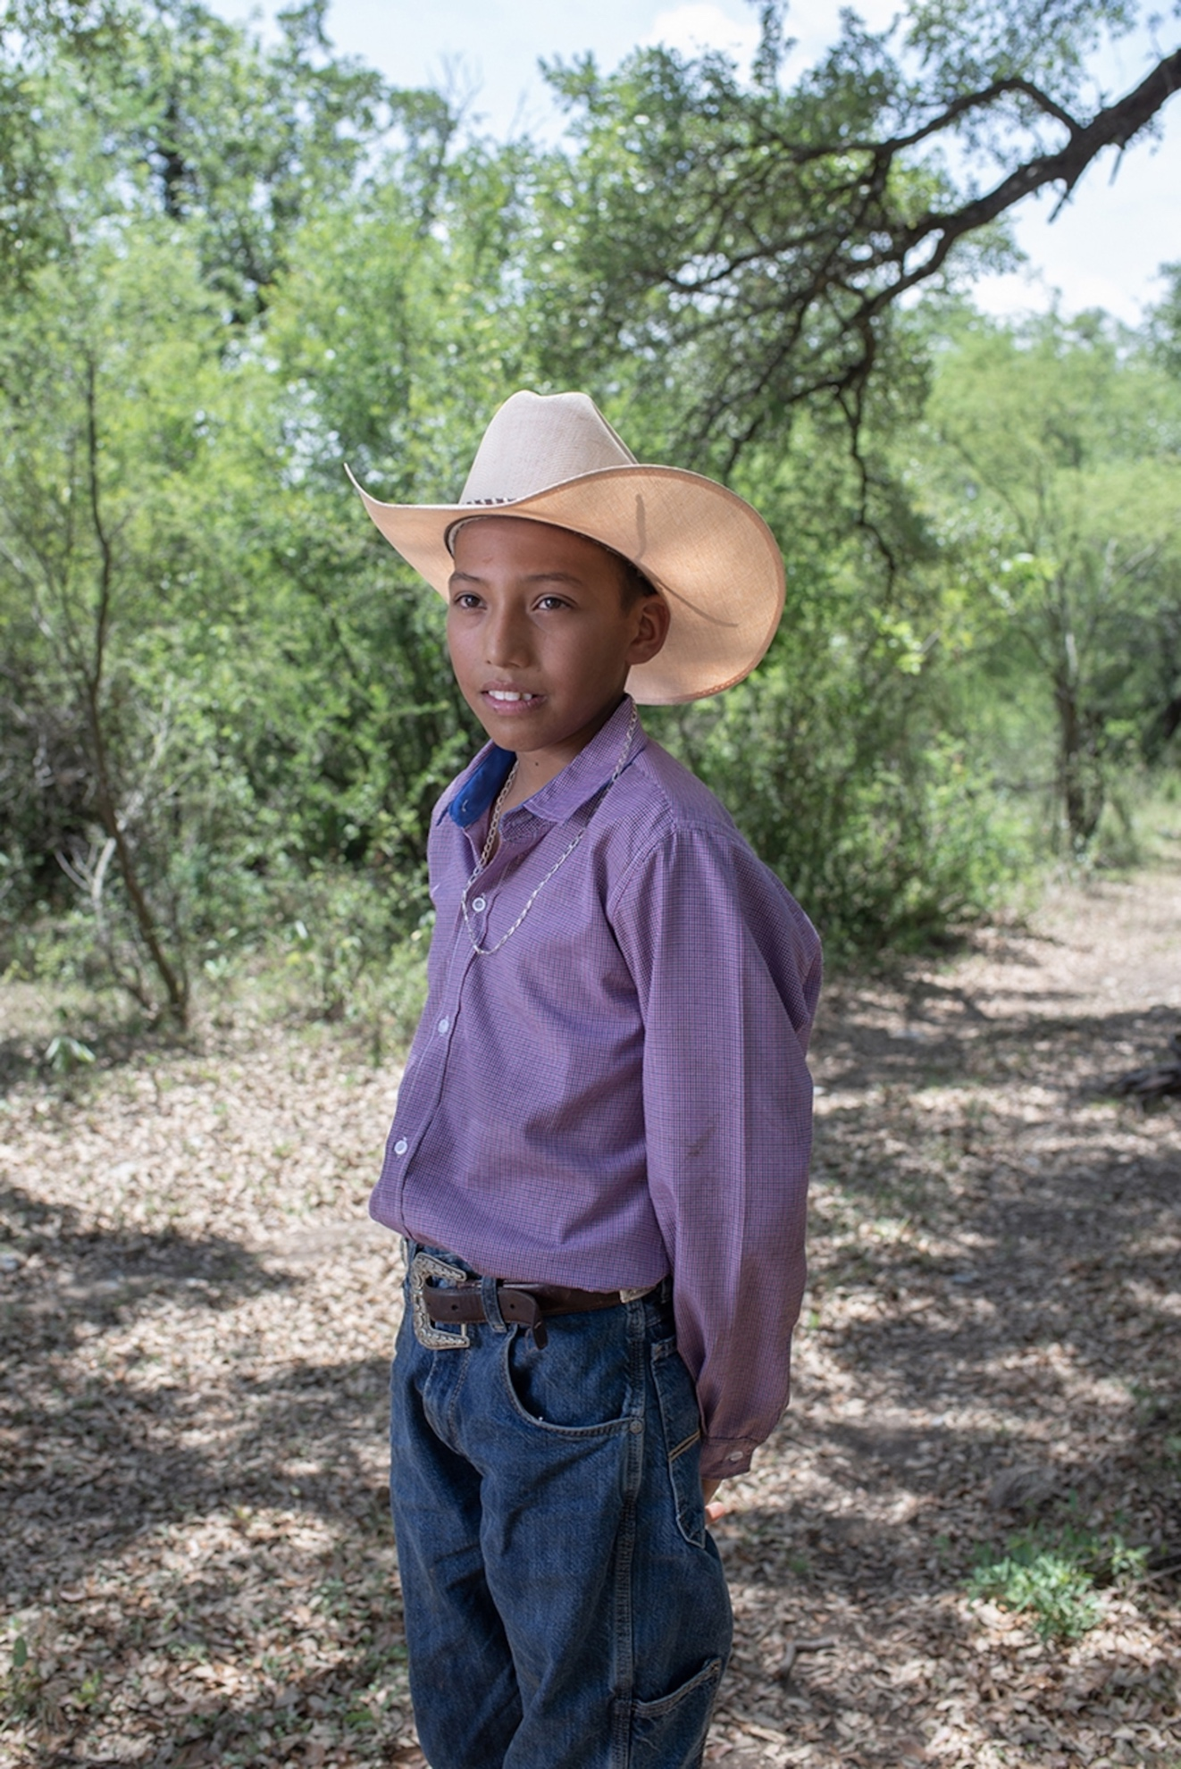
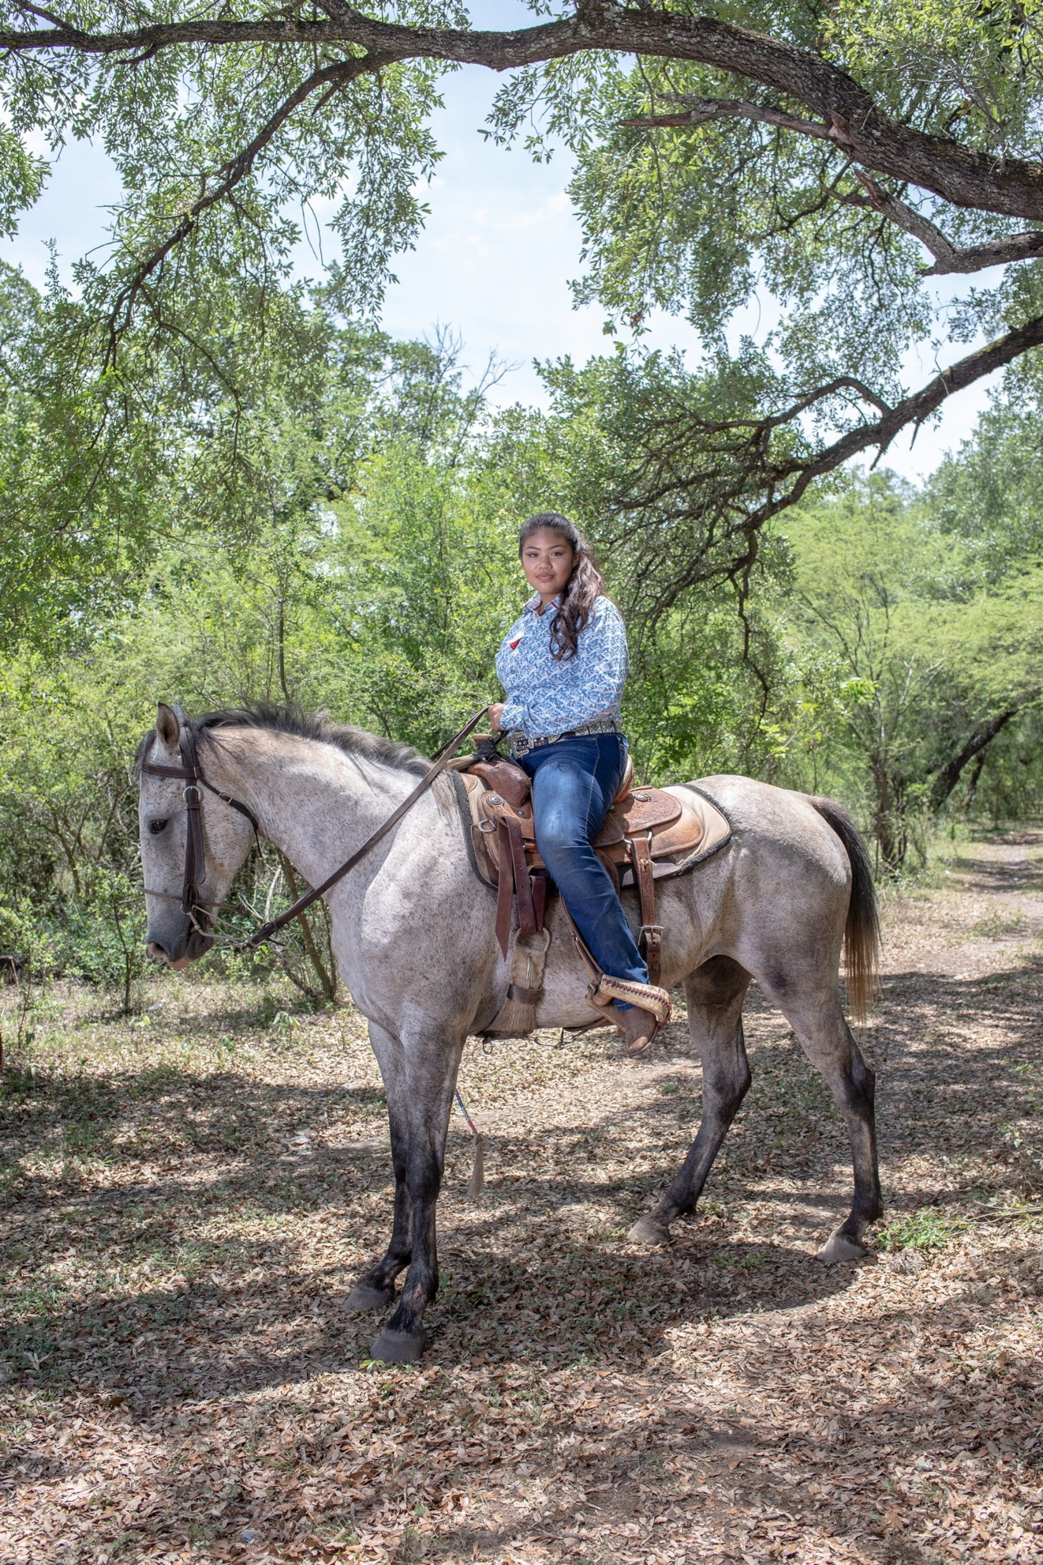
Left: Gustavo wears the traditional dress for men during Juneteenth.
Right: Jennifer celebrates Juneteenth with her community. After the parade of horseback riders arrives into town, Mascogo descendants gather under shade trees to barbecue and boil ears of corn over wood fires.
María Esther Hammack, a historian at the University of Texas at Austin, believes the first Juneteenth celebrations in Nacimiento may have been held as early as the 1870s due to military families traveling back and forth from Nacimiento to Fort Clark in Brackettville, Texas. From 1870 to 1914, Black Seminoles were enlisted by the U.S Army as Seminole Indian “scouts” to defend against other Native American tribes as the U.S. Government expanded into West Texas.
(Remember the Alamo? A battle brews in Texas over history versus lore.)
“People in el Nacimiento had already been enjoying freedom for many years, since their arrival in Mexico in 1850,” says Hammack. “[But] Juneteenth celebration in Coahuila, Mexico began as a means to show solidarity with their brethren in the U.S.,” says Hammack. Black Seminoles still living in Brackettville drive 160 miles south to celebrate Juneteenth with the Mascogos in Nacimiento.
While many details of the earliest celebrations have been lost to time, today’s traditions are a vibrant testament to Mascogo culture. On “Día de Los Negros,” women wearing traditional polka-dot dresses, aprons, and handkerchiefs assemble at the nogalera (a park surrounded by walnut trees) at dawn to begin cooking the communal meal. The cabalgata (a parade of horseback riders) begin their 20-mile journey from the neighboring town of Múzquiz, while the elders lead the community in clap-accompanied spirituals such as “Swing Low, Sweet Chariot.” Dancing to live music and playing bingo, a popular pastime in the town, are also musts.
By noon, the cabalgata arrives at the nogalera, and the townspeople enjoy traditional Afro-Seminole and Mexican dishes, such as corn on the cob, tetapún (sweet potato bread), pumpkin empanadas, pan de mortero (mortar bread), soske (corn-based atole), and asado (slowly cooked pork in hot peppers).
After a quick rest, the Mascogos reconvene at night for a party in the town’s plaza, where they dance the night away.

Threats to the Mascogo culture
With more and more Mascogo descendants leaving Nacimiento for other parts of Mexico and the U.S., Dulce Herrera, a sixth-generation Mascogo and great-granddaughter of Lucia Vazquez Valdez—one of the last surviving negros limpios (pure Blacks)—fears the traditions of her culture will be lost.
She hopes to preserve them by teaching the younger generation of Mascogos the traditional songs and gastronomy of the community. Herrera is also working with her mother, Laura, and great-grandmother to raise the awareness of Mascogo heritage in Mexico.
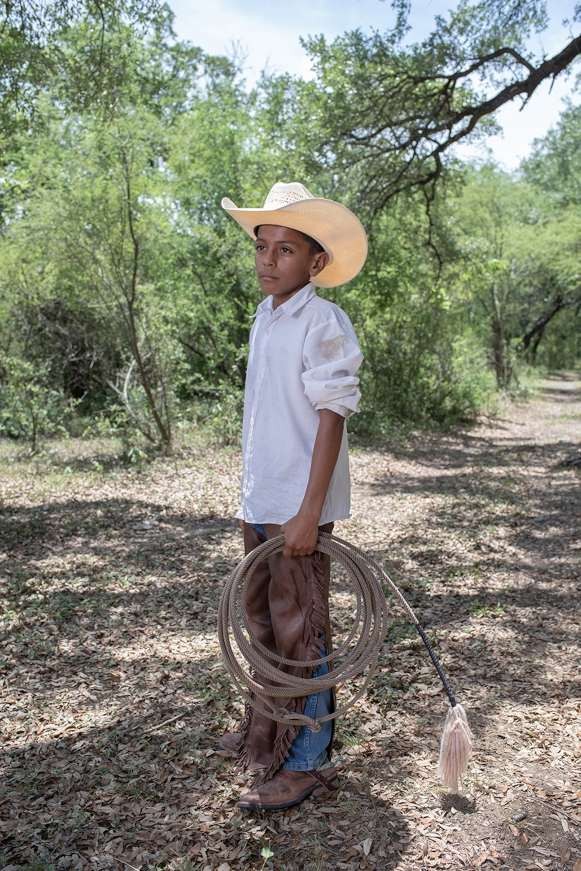
Joseph stands with his horse’s whip. Currently, around 70 families live in Nacimiento and are dedicated to farming and cattle and goat ranching.
“Negros Mascogos is one of the most invisible Afro-descendant communities in Mexico,” she says, citing incidences in which community members were asked for official identification when visiting neighboring towns because “they think we are not Mexican.”
Her efforts have not been in vain. In May 2017, the governor of Coahuila signed a decree recognizing the Mascogos as Indigenous people of Coahuila.
As a result, Herrera and Valdez were able to secure federal funding for huertos familiares (community gardens) to assist community members with planting and selling their crops.
Travelers to Nacimiento can visit the small Museo Comunitario Tribu Negros Mascogos, which contains local artwork and exhibits related to Mascogo history. In 2020, the community also opened a restaurant, El Manà de Cielito, which serves local cuisine, and a hostel, Hospedaje Mascogos. Future plans include boosting cultural tourism by teaching community members to sell embroidered textiles, traditional handicrafts, and organic food as well as developing trails for walking, hiking, and horseback riding.
Taryn White is a D.C.-based travel writer and founder of The Trip Wish List. Follow her journeys on Instagram.
Luján Agusti is a visual storyteller, National Geographic Explorer, and IWMF fellow currently based in Tierra del Fuego, Argentina. Her work on the Mascogos was part of the “Africamericanos” exhibition held by the Government of Mexico and was supported by the International Women’s Media Foundation. Follow her work on Instagram.

Copyright © 1996-2015 National Geographic Society
Copyright © 2015-2021 National Geographic Partners, LLC. All rights reserved

