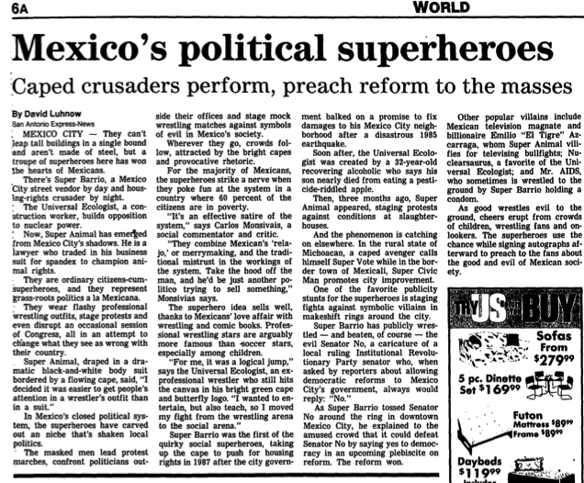

“Mexico’s political superheroes: Caped crusaders perform, preach reform to the masses.” Wisconsin State Journal, Wednesday, August 11, 1993.

